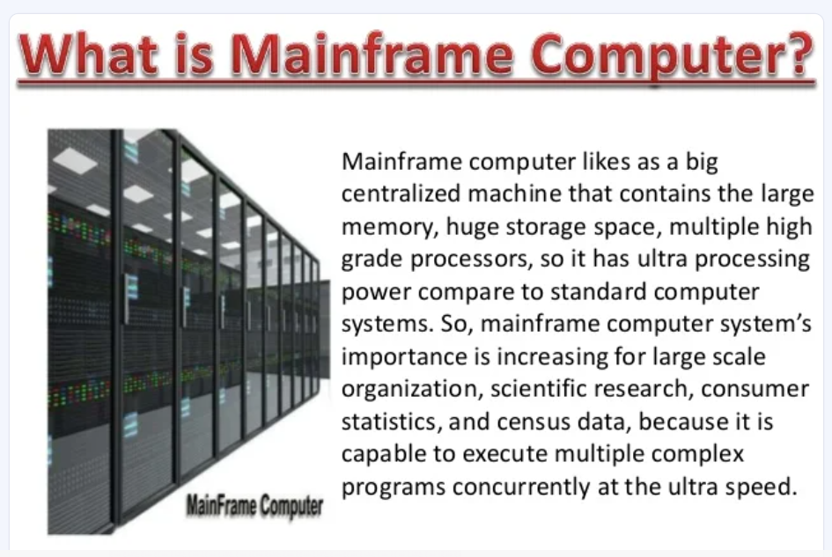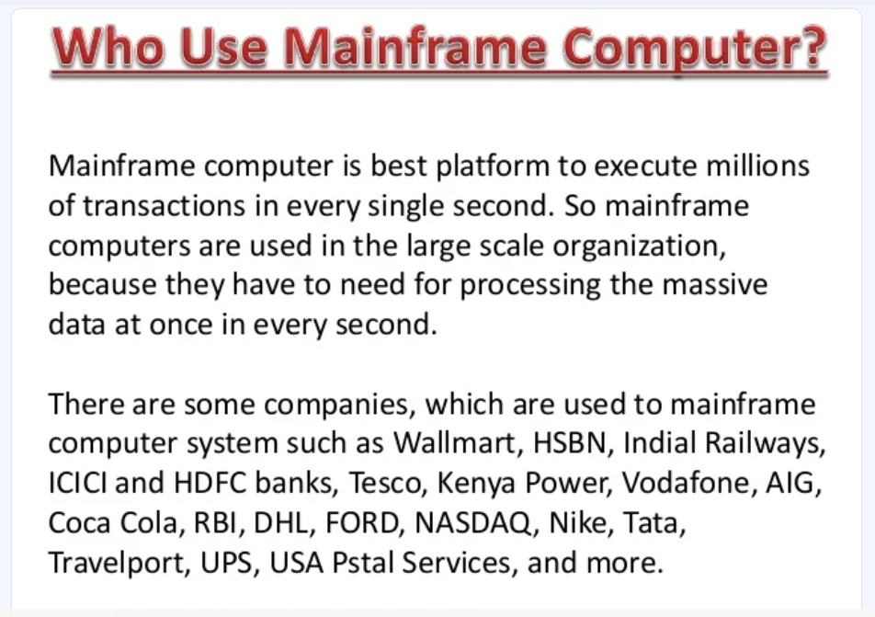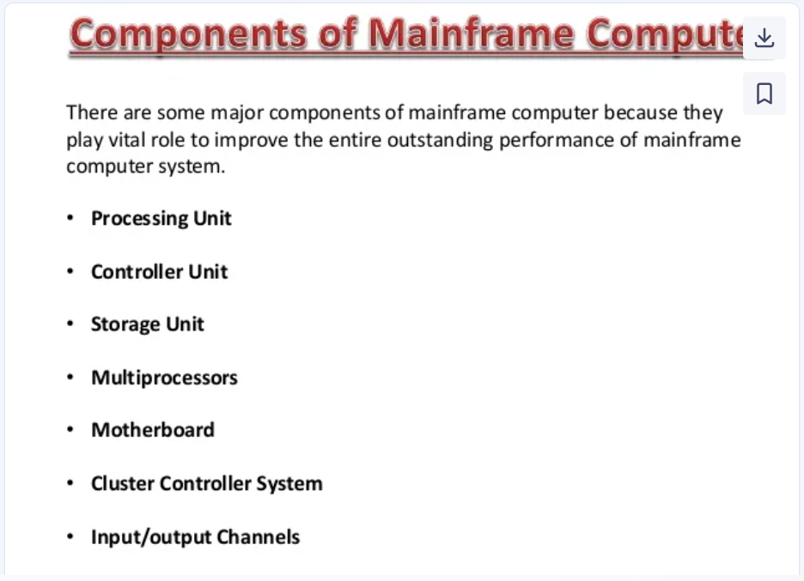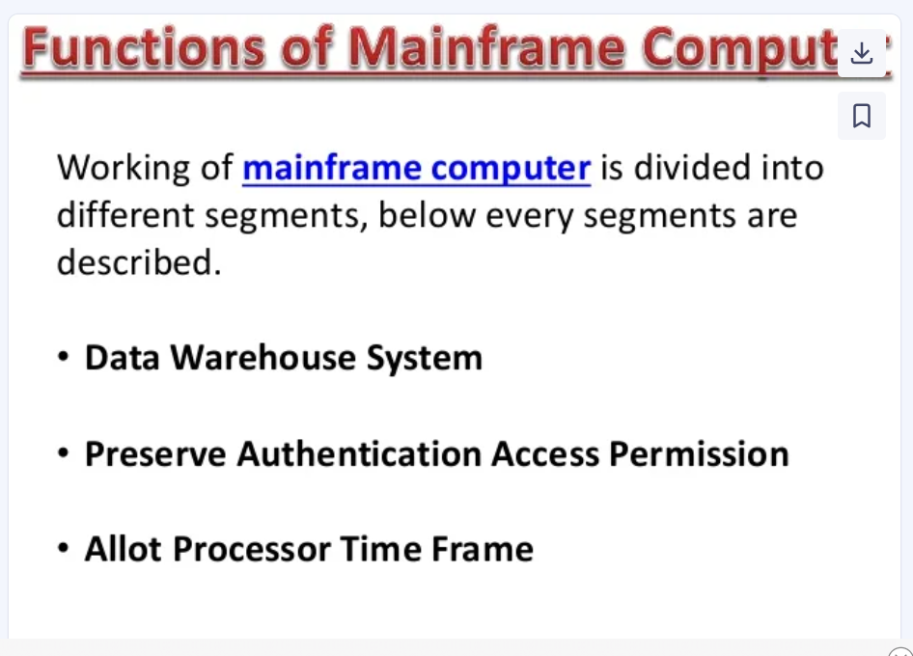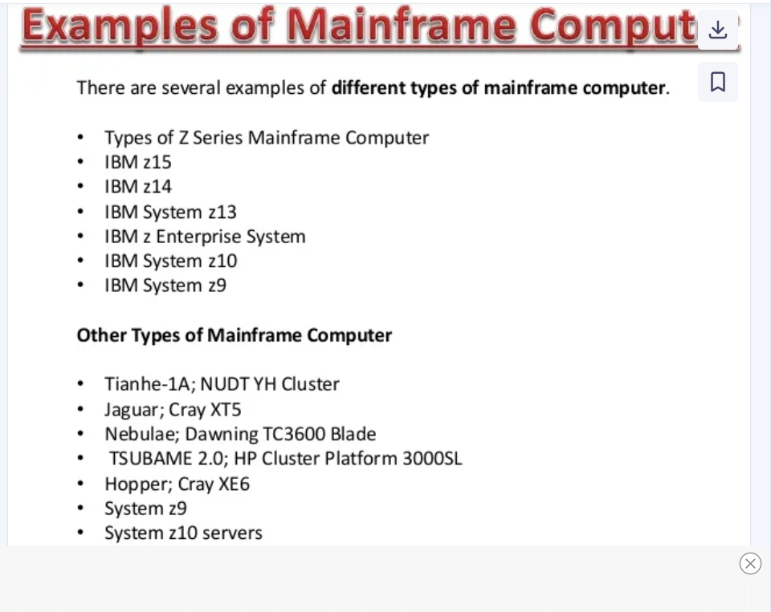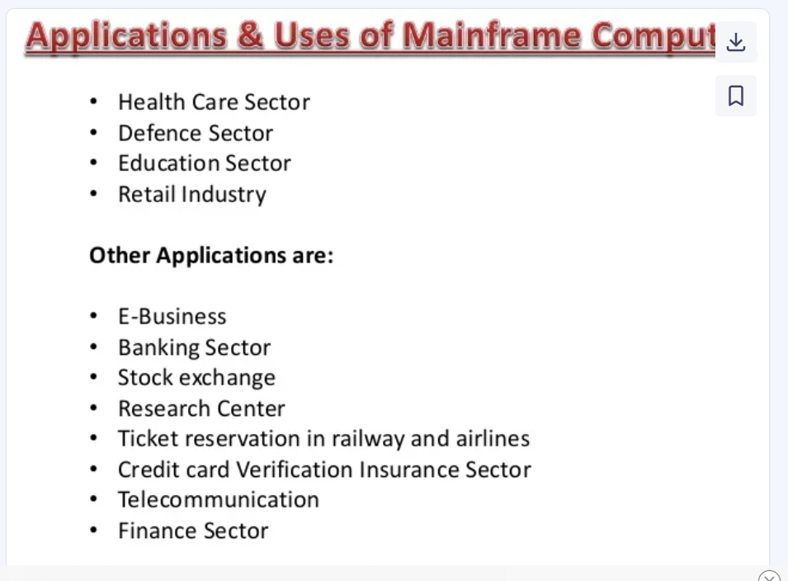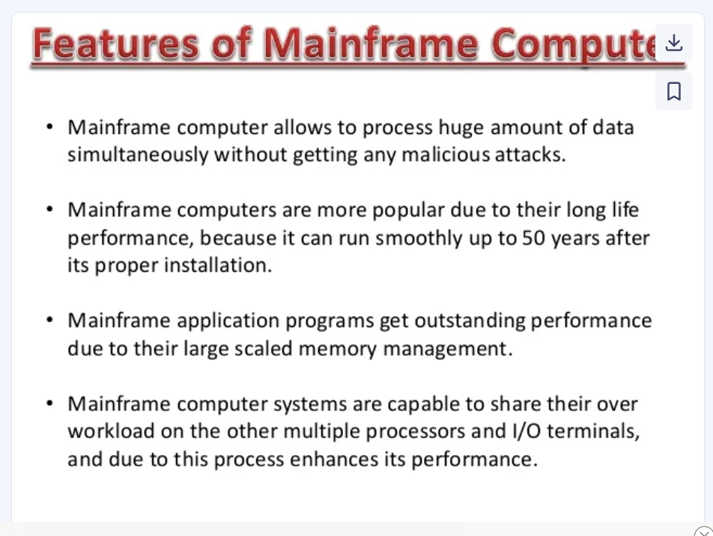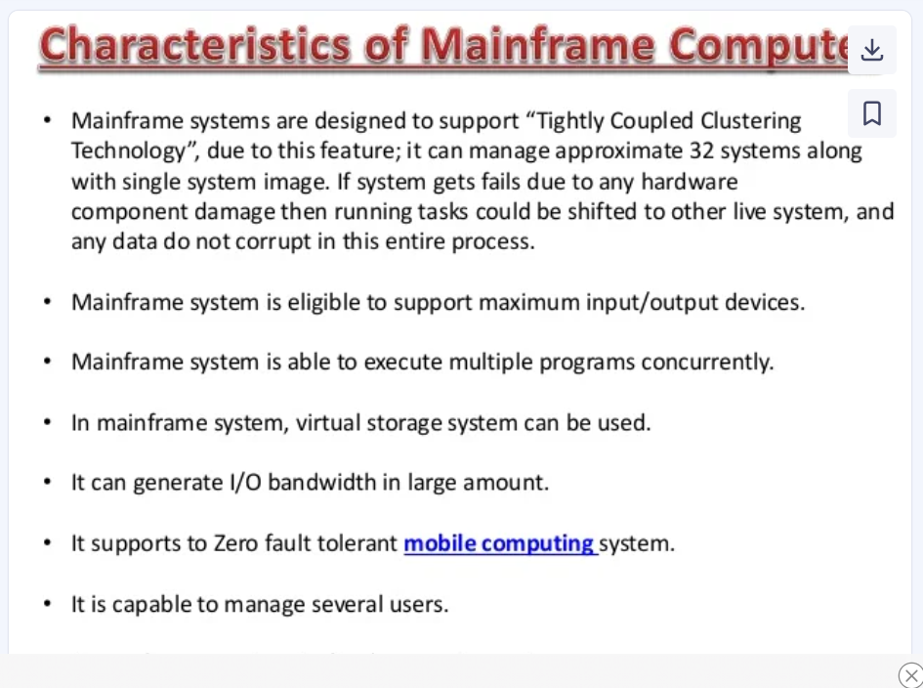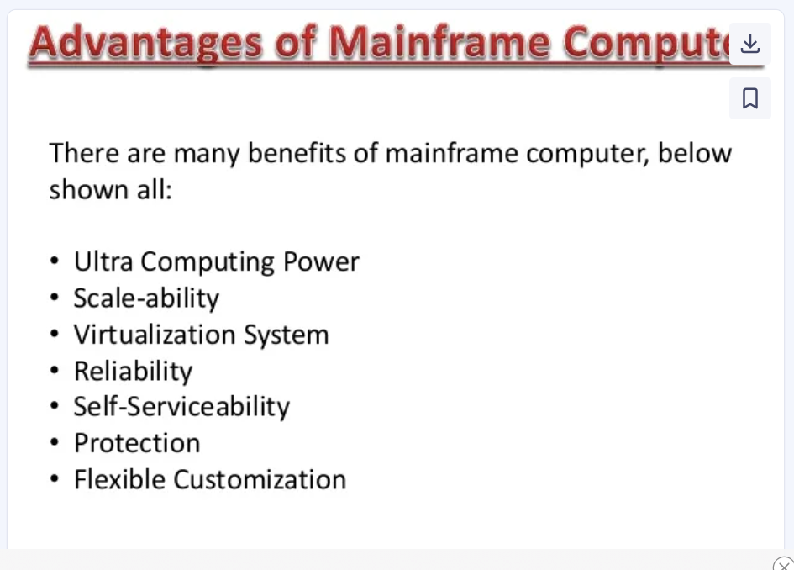 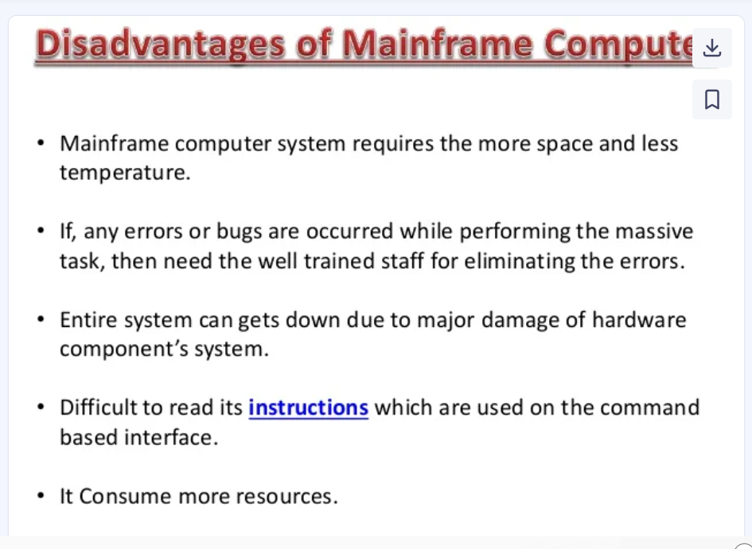

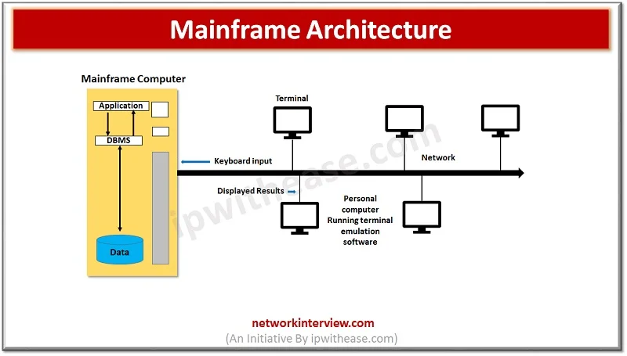

**Mainframe Characteristics**

* Required specialized space to operate and skilled technicians
* Support large number of concurrent users
* Can process millions of transactions per second and handle volumes of data
* It is sturdy by design and can work for years smoothly without glitches with proper installation
* Supports large scale memory management
* Errors can be fix quickly without impacting the performance
* Protection of storage data and information and exchange of data on ongoing basis

**Minicomputer**

**Minicomputers** were very different from their larger counterpart ‘Mainframes’ in terms of price, function, usage and size.

Advent of Minicomputers changed the landscape of IT industry and brought systems in reach to general users. In 1960 Control Data Corporation (CDC) , Packard Bell, and Digital Equipment Corporation introduced Minicomputers  **with PDP**(Programmed Data Processor).

Minicomputers were used by small and medium industry segments for operating businesses. Minicomputer is also referred as**‘Mid-range’** system.

The minicomputers are characterized by one or more processors, supported multiprocessing, and multi-tasking, and meant to be resilient for high workloads, they can be networked, they don’t require any specific power or cooling requirements.

Minicomputers are available in market today in the form of many electronic gadgets such as Smartphones, Tablet PC, iPAD, Drawing tablets , Desktop Mini PC and so on.

These small and powerful gadgets are packed with features and used for gaming, watching videos, net surfing, and a variety of computing tasks. Minicomputers were developed for tasks related to storage of records, calculations, controls etc.

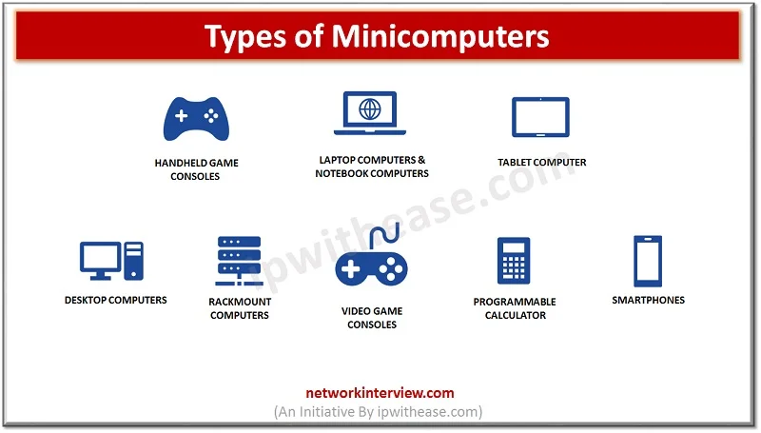

**Minicomputer Characteristics**

* Smaller size than a mainframe computer
* Low in cost than a super and mainframe computer
* Less powerful than a super and mainframe computer but more powerful than microcomputers
* Perform multitasking and multiprocessing
* Suitable for individual use and small businesses
* Ease of use and maintenance
* Small and lightweight easy to carry
* Fast and reliable